ASSIGNMENT - 4

ULTRASONIC SENSOR SIMULATION

|  |  |
| --- | --- |
| Date | 15/11/2022 |
| Team id | PNT2022TMID15090 |
| Project name | Hazardous Area Monitoring for Industrial Plant powered by IoT |
| Maximum Marks | 2 Marks |

# QUESTION-1:

Write a code and connections in wokwi for the ultrasonic sensor. Whenever the distance is less than 100cms send an “Alert” to IBM cloud and display in the device recent events.

# CODE:

#include <WiFi.h> #include<PubSubClient.h>

void callback(char* subscribetopic, byte* payload, unsigned intpayloadLength);

//-------credentials of IBM Accounts------ #define ORG "ytluse"

#define DEVICE_TYPE "2702"

#define DEVICE_ID "12345"

#define TOKEN "O+n)Eh+lNX0y3?rG!8" String data3;

char server[] = ORG ".messaging.internetofthings.ibmcloud.com"; char publishTopic[] = "iot-2/evt/Data/fmt/json";

char subscribetopic[] = "iot-2/cmd/test/fmt/String"; char authMethod[]= "use-token-auth";

char token[] = TOKEN;

char clientId[] = "d:" ORG ":" DEVICE_TYPE ":" DEVICE_ID;

WiFiClient wifiClient;

PubSubClient client(server, 1883, callback ,wifiClient); const int trigPin = 5;

const int echoPin = 18;

#define SOUND_SPEED 0.034 long duration;

float distance; void setup() {

Serial.begin(115200); pinMode(trigPin, OUTPUT); pinMode(echoPin, INPUT); wificonnect(); mqttconnect();

}

void loop() } digitalWrite(trigPin, LOW);

delayMicroseconds(2); digitalWrite(trigPin, HIGH); delayMicroseconds(10); digitalWrite(trigPin, LOW); duration= pulseIn(echoPin, HIGH);

distance = duration * SOUND_SPEED/2;

Serial.print("Distance (cm): "); Serial.println(distance); if(distance<100)

{

Serial.println("ALERT!!"); delay(1000); PublishData(distance); delay(1000);

if (!client.loop()) { mqttconnect();

}

}

delay(1000);

}

void PublishData(float dist) { mqttconnect();

String payload = "{\"Distance\":"; payload += dist;

payload += ",\"ALERT!!\":""\"Distance less than 100cms\"";payload += "}"; Serial.print("Sending payload: ");

Serial.println(payload);

if (client.publish(publishTopic, (char*) payload.c_str())) { Serial.println("Publish ok");

} else {

Serial.println("Publish failed");

}

}

void mqttconnect() {

if (!client.connected()) { **Serial**.print("Reconnecting client to "); **Serial**.println(server);

while (!!!client.connect(clientId, authMethod, token)) {

**Serial**.print("."); delay(500);

}

initManagedDevice();

**Serial**.println();

}

}

void wificonnect()

{

**Serial**.println(); **Serial**.print("Connecting to "); WiFi.begin("Wokwi-GUEST", "", 6);

while (WiFi.status() != WL_CONNECTED) { delay(500);

**Serial**.print(".");

}

**Serial**.println(""); **Serial**.println("WiFi connected"); **Serial**.println("IP address: ");

**Serial**.println(WiFi.localIP());

}

void initManagedDevice() {

if (client.subscribe(subscribetopic)) { **Serial**.println((subscribetopic)); **Serial**.println("subscribe to cmd OK");

} else {

**Serial**.println("subscribe to cmd FAILED");

}

}

void callback(char* subscribetopic, byte* payload, unsigned int payloadLength)

{

**Serial**.print("callback invoked for topic: ");

**Serial**.println(subscribetopic);

for (int i = 0; i < payloadLength; i++) {

//Serial.print((char)payload[i]);data3 += (char)payload[i];

}

**Serial**.println("data: "+ data3);data3="";

}

# DIAGRAM.JSON:

{

"version": 1,

"author": "KESAVAMOORTHI M 19EC042",

"editor": "wokwi", "parts": [

{ "type": "wokwi-esp32-devkit-v1", "id": "esp", "top": -4.67, "left": -114.67,

"attrs": {} },

{ "type": "wokwi-hc-sr04", "id": "ultrasonic1", "top": 15.96, "left": 89.17,"attrs": {} }

],

"connections": [

[ "esp:TX0", "$serialMonitor:RX", "", [] ],

[ "esp:RX0", "$serialMonitor:TX", "", [] ],[ "esp:VIN",

"ultrasonic1:VCC", "red",

[ "h-37.16", "v-178.79", "h200", "v173.33", "h100.67" ]

],

[ "esp:GND.1", "ultrasonic1:GND", "black", [ "h39.87", "v44.04", "h170" ] ],

[ "esp:D5", "ultrasonic1:TRIG", "green", [ "h54.54", "v85.07", "h130.67" ] ],

[ "esp:D18", "ultrasonic1:ECHO", "green", [ "h77.87", "v80.01", "h110" ] ]

]

}

# CIRCUIT DIAGRAM:

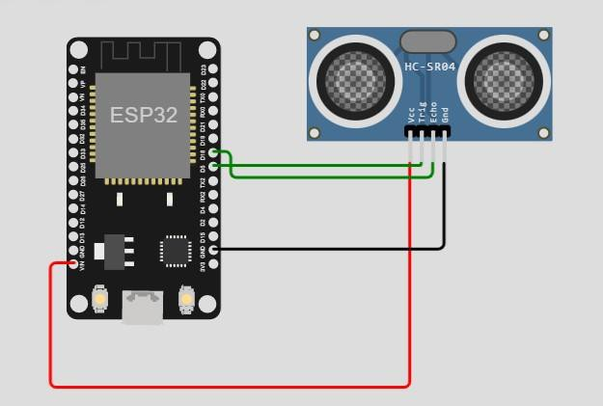

Circuit Diagram For Ultrasonic Sensor Simulation In Wokwi

# WOKWI OUTPUT:

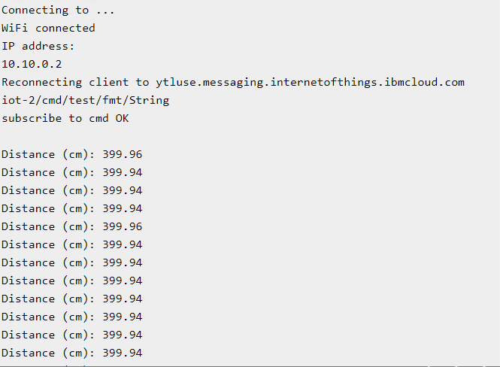

Wokwi Output For Ultrasonic Sensor Simulation In Wokwi

# IBM CLOUD OUTPUT:

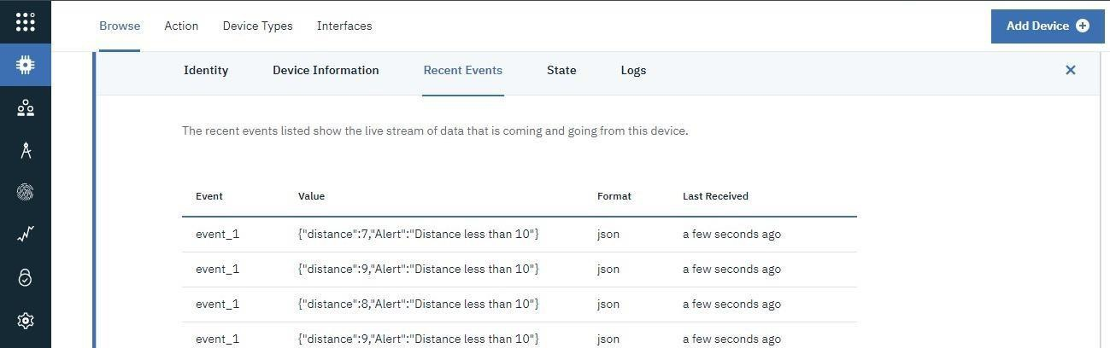

IBM CLOUD OUTPUT